Curso - PTM
N. | Designação | Conteúdo | Imagem | Duração
1 | Professional vs. Retail Traders 101 |  |  | 56:26
2 | Professional vs. Retail Traders 102 |  |  | 46:13
3 | Distribution and Odds Calculation 1 |  | 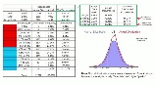 | 37:26
4 | Distribution & Odds Calculation 2 – Excel Training |  | 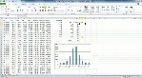 | 50:03
5 | Implied Volatility Assessment 1 |  | 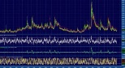 | 36:02
6 | Implied Volatility Assessment 2 – with Excel |  | 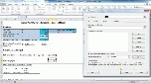 | 17:47
7 | Volatility Assessment 3 – with Excel Training |  |  | 40:18
8 | W.I.S.H. Framework – Getting Perspective 1 |  | 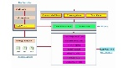 | 32:46
9 | W.I.S.H. Framework – Getting Perspective 2 |  | 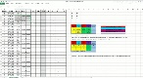 | 38:01
10 | Correlating Indicators 1 | ISM - PMI | 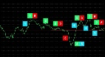 | 44:20
11 | Correlating Indicators 2 | NMI |  | 13.58
12 | Correlating Indicators 3 | UMCSI – Univ. Michigan Consumer Index | 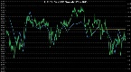 | 17.32
13 | Correlating Indicators 4 | Building Permits |  | 29:33
14 | Correlating Indicators 5 | Europe |  | 30:22
15 | Correlating Indicators 6 – with Excel Training |  | 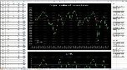 | 1:03:31
16 | Correlating Indicators 7 | China - PMI | 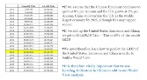 | 31:08
17 | Recap – What We Have Learnt So Far | Resumo |  | 11:07
18 | Drilling from the Top Down 1 – with Excel |  | 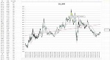 | 1:21:05
19 | Drilling from the Top Down 2 – Real Examples |  |  | 1:05:00
20 | Gate Keeping 1 (Deploying Capital) |  | 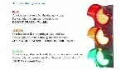 | 41:26
21 | Gate Keeping 2 (Deploying Capital) – with Excel |  | 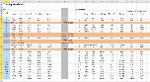 | 1:02:54
22 | Having Discipline 1 – Risk Management with Excel |  |  | 1:26:05
23 | Having Discipline 2 – Risk Management with Excel |  | 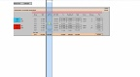 | 1:14:55
24 | Having Discipline 3 – Risk Management with Excel | Cálculo do Beta | 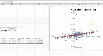 | 26:45
25 | Having Discipline 4 – Self Awareness Statistics |  | 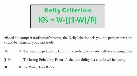 | 28:58
26 | Day Trading – Approach, Discipline, Resources |  | 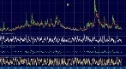 | 1:15:44
27 | Trading Plan – Actionable Steps & Implementation |  | 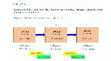 | 23:24

Curso - Forex
N. | Designação | Conteúdo | Imagem | Duração
1 | FOREX Market Foundation 1 - Opportunity Set |  |  | 1:02:33
2 | FOREX Market Foundation 2 - Regimes |  | 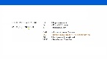 | 1:57:02
3 | FOREX Market Foundation 3 - Infrastructure |  | 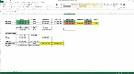 | 3:14:53
4 | FOREX Market Foundation 4 - Basic Computational Methods |  | 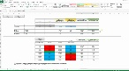 | 1:57:38
5 | Advanced Computational Methods with Excel Training - Vol Assessment 1 |  | 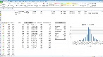 | 2:00:07
6 | Advanced Computational Methods with Excel Training - Vol Assessment 2 |  | 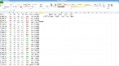 | 54:11
7 | Macro Fundamentals Driver 1 - with Excel Examples | 7A - PMI / 7B – NMI; UMCSI; B. Permits |  | 2:40:36
8 | Macro Fundamentals Driver 2 - with Excel Examples | M2 – Money Supply | 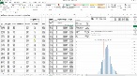 | 1:13:28
9 | Macro Fundamentals Driver 3 - with Excel Examples | UMCSI – Univ. Michigan Consumer Index | 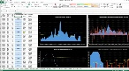 | 1:00:44
10 | Macro Fundamentals Driver 4a - with Excel Examples | Inflation |  | 43:20
11 | Macro Fundamentals Driver 4b- with Excel Examples | Europe | 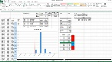 | 50:53
12 | Macro Fundamentals Driver 4c - with Excel Examples | Inflation | 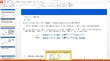 | 39:53
13 | Macro Fundamentals Driver 4d- with Excel Examples |  | 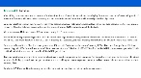 | 30:13
14 | Macro Fundamentals Driver 5 - with Excel Examples | NFP | 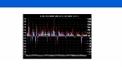 | 52:11
15 | Macro Fundamentals Driver 6 - with Excel Examples |  | 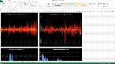 | 1:12:34
16 | Recap - Overview of everything learnt so far | Resumo |  | 57:03
17 |  |  |  | 11:07
18 |  |  |  | 1:21:05
19 |  |  |  | 1:05:00
20 |  |  |  | 41:26
21 |  |  |  | 1:02:54
22 |  |  |  | 1:26:05
23 |  |  |  | 1:14:55
24 |  |  |  | 26:45
25 |  |  |  | 28:58
26 |  |  |  | 1:15:44
27 |  |  |  | 23:24

Endogenous Driver Analysis | Driver | Code |  | Source
Leading Indicators Surveys | Business Sentiment - ISM Manufacturing | ISM |  | http://www.ism.ws/ismreport/mfgrob.cfm
 | Business Sentiment - NMI Services | NMI |  | http://www.ism.ws/ismreport/nonmfgrob.cfm
 | Consumer Sentiment - UMCSI | UMCSI |  | http://www.sca.isr.umich.edu/
 | Building Permits | BP |  | http://www.census.gov/construction/bps/uspermits.html
Money Supply | M2 | M2 |  | https://research.stlouisfed.org/fred2/series/M2/downloaddata
Interest Rates | Federal Reserve Benchmark Rate | IR% |  | https://research.stlouisfed.org/fred2/series/FEDFUNDS/downloaddata
Inflation | Consumer and Business Inflation | CPIAUCSL |  | http://research.stlouisfed.org/fred2/series/CPIAUCSL/downloaddata
 |  | CPILFESL |  | http://research.stlouisfed.org/fred2/series/CPILFESL/downloaddata
 |  | PPI All |  | https://research.stlouisfed.org/fred2/series/PPIFGS/downloaddata
 |  | PPI Core |  | https://research.stlouisfed.org/fred2/series/PPILFE/downloaddata
Employment | Employment Situation Report (ESR) | NFP |  | http://data.bls.gov/pdq/SurveyOutputServlet?request_action=wh&graph_name=CE_cesbref1
Balance Sheets and Sovereign Risk |  |  |  | http://research.stlouisfed.org/fred2/categories/5
 | Government Debt to GDP Ratio | Govt |  | http://research.stlouisfed.org/fred2/categories/5
 | Government S/D % GDP | Govt |  | http://research.stlouisfed.org/fred2/categories/5
 | Interest / GDP | Govt |  | http://research.stlouisfed.org/fred2/categories/5
 | Liquidity | Govt |  | http://research.stlouisfed.org/fred2/categories/5
 | US 10 Year Treasury Benchmark | Govt |  | https://research.stlouisfed.org/fred2/series/WGS10YR/downloaddata
 | CB Balance Sheet as % of GDP | CBBS |  | https://research.stlouisfed.org/fred2/series/WALCL/downloaddata

